KEY MILESTONE 1
Course Registration System

Database Management Systems Lab

Submitted By:
Jamal khan(22pwcse2203)
Naveed Ahmad(22pwcse2165)
Omer khan(22pwcse2130)
Section:
B

Submitted to:
Mam Sumayyea Salahudin

Department of Computer Systems Engineering
University of engineering and technology, Peshawar

Entity and Attribute Description – Course Registration System:

ENTITY | DESCRIPTION | ATTRIBUTES
Student | Represents a student enrolled in the institution | student_id (PK), first_name, last_name, email, phone, department_id (FK)
Instructor | Represents an instructor teaching courses | instructor_id (PK), first_name, last_name, email, phone, department_id (FK)
Department | Represents an academic department | department_id (PK), department_name
Course | Represents a course offered by a department | course_id (PK), course_name, course_code, credit_hours, department_id (FK), instructor_id (FK)
Registration | Represents a student's registration to a course | registration_id (PK), student_id (FK), course_id (FK), semester, registration_date
Schedule | Represents a course schedule | schedule_id (PK), course_id (FK), classroom_id (FK), day_of_week, start_time, end_time
Classroom | Represents a classroom where courses take place | classroom_id (PK), room_number, building, capacity

Business Rules :
- Student Registration
  - A student must be registered in exactly one department.
  - A student can register for multiple courses, but the same course cannot be registered twice in the same semester.
- Instructor Assignment
  - An instructor can teach multiple courses, but each course is taught by only one instructor.
  - An instructor must belong to a department.
- Course Management
  - Each course must be associated with one department.
  - Each course must have a unique course code.
  - A course may be scheduled in one or more time slots, but not overlapping ones.
- Classroom Allocation
  - A classroom can host multiple courses, but not at the same time.
  - The classroom capacity must be sufficient for the number of students registered in the course.
- Registration Constraints
  - A student cannot register for more than a fixed number of credit hours per semester (e.g., 18 credit hours).
  - A registration record must be created before the course start date.
- Scheduling Rules
  - Each schedule must specify the classroom, day of the week, start time, and end time.
  - A course cannot be scheduled in overlapping time slots for the same instructor.
- Department Structure
  - Each department must have at least one course and one instructor.
  - Departments must have unique names.
- Data Integrity
  - All foreign key relationships must be maintained (e.g., a student cannot be assigned to a non-existent department).
  - Deleting a course should remove all associated schedules and registrations (with confirmation).

ENTITY RELATIONSHIP DIAGRAM (ERD):

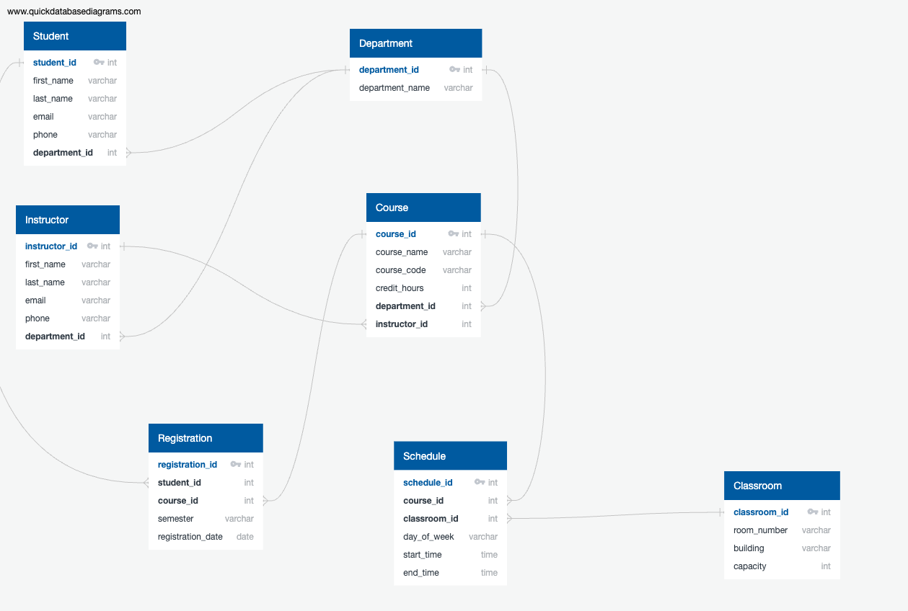

References:
- ChatGPT by OpenAI – https://chat.openai.com
- Google Gemini – https://gemini.google.com
- DBDiagram.io – https://dbdiagram.io
- QuickDBD – https://www.quickdatabasediagrams.com

